Slide 1 | 
Slide 2 | 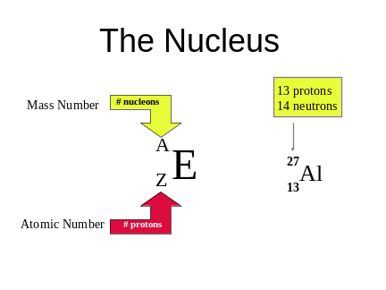
Slide 3 | 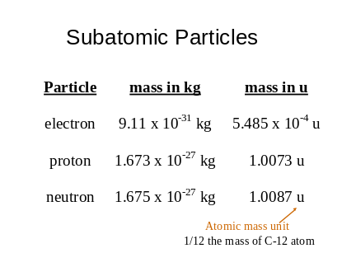
Slide 4 | 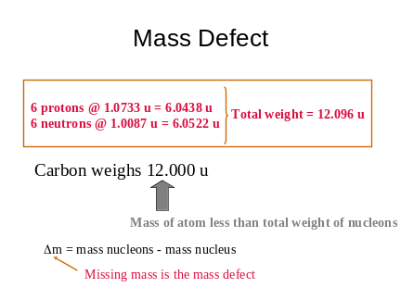
Slide 5 | 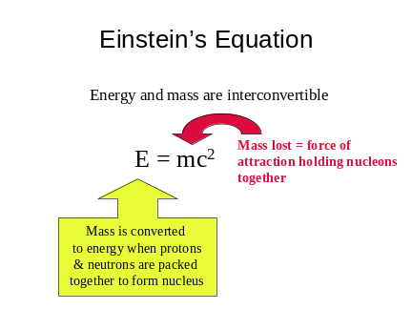
Slide 6 | 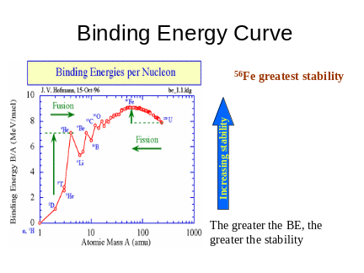
Slide 7 | 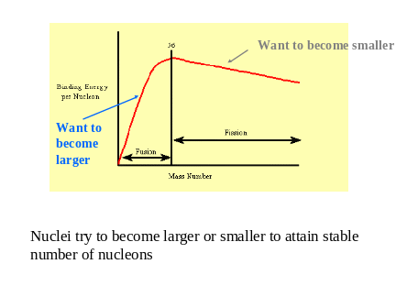
Slide 8 | 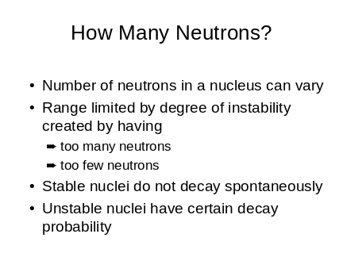
Slide 9 | 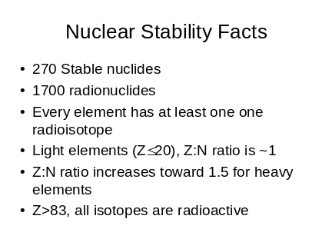
Slide 10 | 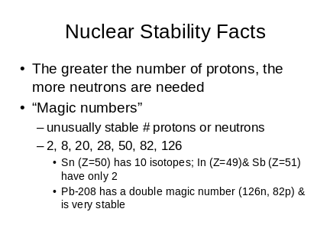
Slide 11 | 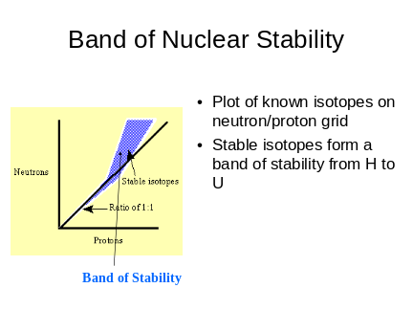 | Z:N ratios to either side of this band too unstable & are not known
Slide 12 | 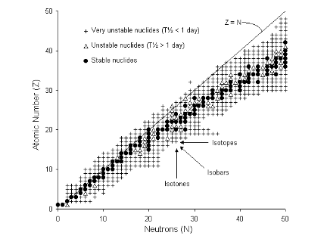
Slide 13 | 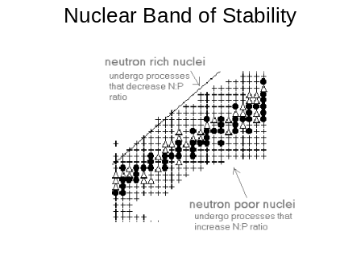
Slide 14 | 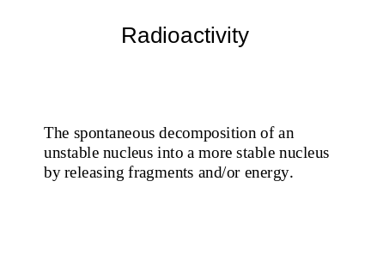
Slide 15 | 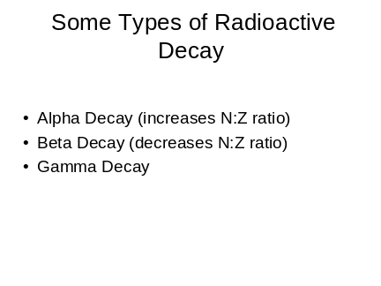
Slide 16 | 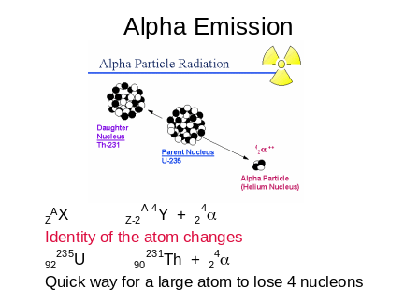
Slide 17 | 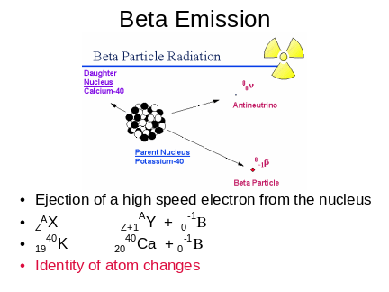
Slide 18 | 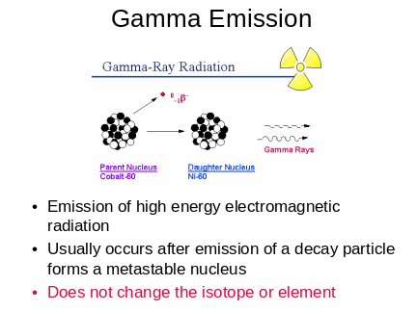
Slide 19 | 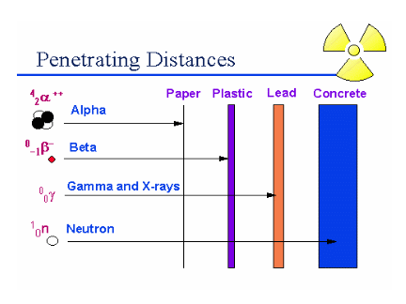 | Alpha Particles  relatively heavy and doubly (+2) charged  lose energy quickly in matter  Beta Particles  much smaller and (-1) charged  interact more slowly with matter  Gamma Rays & X-rays  high energy  more lengthy interaction with matter  Hazards of Radiation Types  Alpha Emissions  easily shielded  considered hazardous if alpha emitting material is ingested or inhaled  Beta Emissions  shielded by thin layers of material  considered hazardous is a beta emitter is ingested or inhaled  Gamma Emissions  need dense material for shielding  considered hazardous when external to the body

