Majors at Western
What Can I Do With a Major In... https://www.wou.edu/student/career/majors/default.html
Career Assessments (the text that was provided)
Majors by Holland Codes
Career Planning Timetable

Majors by Holland Codes

MATCHING PERSONALITIES WITH MAJORS & CAREERS
Majors and careers can be clustered into 6 broad interest areas that correspond to 6 different personality types. Based on the research of Dr. John Holland, this clustering system provides a preliminary way to identify undergraduate majors and careers that might be a satisfying fit for you. Because personality, majors, and careers are complex, keep in mind that any type can enjoy any major, they may just approach it differently than the typical person in that major

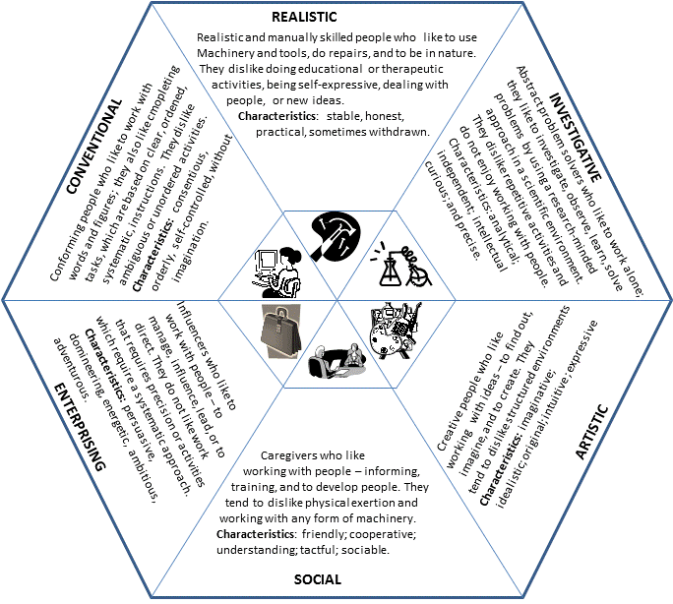
Undergraduate Students
College of Education
Health & P.E.
Community Health Education SEI
School Health Education SEI
Exercise Science IRS
Physical Education SRE
Health & P.E. Minors SRE
Special Education
American Sign Language Studies SA
American Sign Language ASL/English Interpreting AS
Special Education & Rehabilitation Counseling minor SAE
Teacher Education
Baccalaureate initial license SEC
(Early Childhood, Elementary, Middle,
Secondary)
Post-baccalaureate initial license SEC
(Early Childhood, Elementary, Middle,
Secondary)

College of Liberal
Arts & Sciences
Behavioral Sciences
Psychological Sciences ISA
Gerontology SIA
Business & Economics
Business ECS
Accounting CRS
Finance ESR
General Business EC
International Business EIC
Management ESC
Marketing EAS
Production/Operations Management ERC
Sport Management ERS
Economics IAS

Computer Science
Computer Science ICE
Computer Science/Mathematics ICR
Informations Systems EIR
Creative Arts
Art ASR
Graphic Design AES
Music ASI
Theatre & Dance AER
Fire Service Administration REI

Humanities
Communication Studies EAS
English Literature AIS
English Writing AES
Linguistics ISA
French AIS
German AIS
Spanish AIS
Philosophy SAI
Religious Studies SAI
Interdisciplinary Studies Depends on focus

Natural Science & Mathematics
Biology IRS
Chemistry IRE
Earth & Physical Sciences IRE
Mathematics IRE
Nursing (OHSU/WOU partnership) ISA
Physics IRE

Social Science
Anthropology IRE
Chicano/a Studies SAI
Criminal Justice SER
Environmental Studies IRE
Gender Studies ISE
Geography IRE
History SIE
Latin American Studies SIA
Legal Studies ESA
Political Science SEI
Public Policy & Administration SEI
Social Science program IES
Sociology IES

