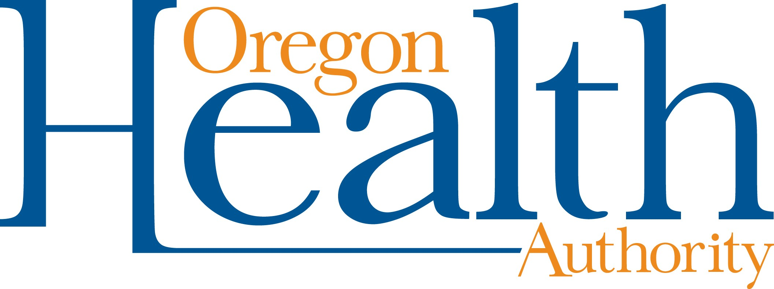

Interim public health recommendations for response to COVID-19 cases in Oregon schools
March 8, 2020

Background
Oregon has recently seen COVID-19 cases in people without high-risk exposures (i.e., travel to affected regions or contact with known cases). This means COVID-19 has spread in communities in Oregon.
Community-wide measures like hand hygiene and staying home when ill are essential to decrease further community spread. Measures such as complete closure of a school or schools for extended periods of time come with significant detrimental effects to communities, and their public health benefit in containing the spread of COVID-19 remains unclear at this point. Other measures, outlined below, should be deployed by schools first, with extended closures viewed as a measure of last resort.

School-based measures
School-based measures for mitigation of community spread of COVID-19 are advised, including telling students, their parents and school staff to remain home while ill, screening students for cough illness at the start of the school day, reinforcement of handwashing, and increasing frequency of cleaning high- touch surfaces. Additional measures are based on the concept of “social distancing” – i.e., reducing interactions between people, such as staggering lunches and recesses or dividing into smaller groups.
Although aggressive measures such as complete closure of a school or schools for extended periods of time are being used by numerous countries and sporadically in the United States, data regarding the appropriate timing, duration, geographic scale and effectiveness of such measures are lacking.
Nationally and in Oregon, few children have tested positive for COVID-19. Older populations, especially those with underlying health conditions, are at far greater risk. The public health benefit of school closures is likely low compared to the negative impacts on communities and populations facing health and social inequities. More than 22,000 students in Oregon, for example, experienced some form of homelessness in 2019. For many students, schools may be the only place to access regular meals or medical care. Many parents and caregivers have jobs that don’t offer paid time off. Furthermore, extended school closures might increase contact rates within households or at other social gatherings.
The Centers for Disease Control and Prevention (CDC) has issued Interim Guidance for Administrators of US Childcare Programs and K–12 Schools to Plan, Prepare, and Respond to Coronavirus Disease 2019 (COVID-19). This document recommends that schools collaborate with local health officials to develop plans to protect the school community while minimizing disruption to teaching and learning.
In 2017, CDC published Community Mitigation Guidelines to Prevent Pandemic Influenza. Although focused on influenza, many of the recommendations apply broadly to large outbreaks of viral respiratory disease. CDC concluded that preemptive, coordinated school dismissals might be recommended during the early stages of a severe or extreme influenza pandemic, but did not find sufficient evidence to advise such dismissals during an influenza pandemic of mild or moderate clinical severity, similar to what we are currently seeing with COVID-19 in Oregon.
The Oregon Health Authority Public Health Division has a High-Impact Pathogen Plan of Operations that identifies assets for use in planning for and identifying high-impact communicable pathogens, monitoring related health effects, and mitigating spread to limit the health burden from outbreaks of these pathogens.

Recently revised in December 2019, it recommends that closure of facilities such as schools can be considered for more severe illnesses, and only after weighing the benefits against disruption to communities.

Recommendation
At this time, OHA recommends against closing schools and campuses where no cases of COVID-19 are present. OHA also recommends that schools, colleges and universities consider all alternatives before closing a school, college or university in the event that a COVID-19 case is detected among students or staff. Schools, colleges and universities should make decisions in concert with public health authorities, based on real-time information about COVID-19 and its transmission and using public health best practices. Meanwhile, schools, colleges and universities should emphasize the simple things people can do to keep healthy and remind students, faculty and staff who are ill not to attend school and remain at home. OHA will continue to reassess this recommendation as the outbreak continues.

References
Qualls N, Levitt A, Kanade N, et al. Community Mitigation Guidelines to Prevent Pandemic Influenza — United States, 2017. MMWR Recomm Rep 2017;66(No. RR-1):1–34. DOI: http://dx.doi.org/10.15585/mmwr.rr6601a1
Centers for Disease Control and Prevention. Interim Guidance for Administrators of US Childcare Programs and K-12 Schools to Plan, Prepare, and Respond to Coronavirus Disease 2019, https://www.cdc.gov/coronavirus/2019-ncov/specific-groups/guidance-for-schools.html
Oregon Health Authority Public Health Division. High-Impact Pathogen Plan of Operations (HIPPO), December 2019.

