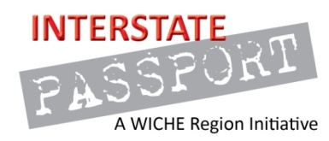
DRAFT PLOs Critical Thinking, April 27th, 2015
Critical thinking is a cross-disciplinary process based on information literacy that uses inquiry and analysis, and leads to problem solving. Critical thinking is also a habit of mind characterized by the comprehensive exploration of issues, ideas, artifacts, and events before accepting or formulating a judgment or conclusion. Critical thinkers deeply reflect on the process and each of the steps below and return to each step as necessary.
- Problem Setting: Identify a problem or question and its component parts.
- Recognize Assumptions: Recognize and assess personal and other relevant underlying assumptions.
- Evidence: Identify, gather, and analyze the information/data necessary to address the problem or question.
- Evaluate: Evaluate information/data for credibility (e.g. bias, reliability, validity) and relevance to a situation.
- Context: Identify relevant (disciplinary) context(s) including, as appropriate, principles, criteria, concepts, values, histories, and theories.
- Reasoning/Conclusion: Develop logical conclusions, solutions, and outcomes that reflect an informed, well-reasoned evaluation.

