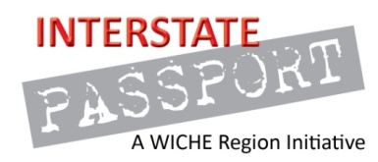
Interstate Passport Initiative

Creative Expression
DRAFT Passport Learning Outcomes

Interpretive and creative expression of the potential and limits of the human condition relies on critical analysis of specific texts or works to support its claims. Relationship to Institutions’ Passport Block: This area includes disciplines such as music, visual arts, design, theater, film, media, literature, architecture, and others.

Through the study of literary, performing and/or visual arts, students will:

- Employ fundamental discipline-specific principles, terminology, skills, technology, and methods (Basic Knowledge).

- Identify, explain and/or demonstrate relationships among societal, cultural, and historical contexts (History and Cultures).

- Demonstrate knowledge of and empathy for the diversity of values, beliefs, ideas, and practices embodied in the human experience (Ethics).

- Engage in a creative process through experimentation, reflection, tolerance for failure, and revision (Creative Process).

- Use appropriate methods and tools to analyze, interpret and critique creative processes, works, and/or presentations (Aesthetics and Analysis).

