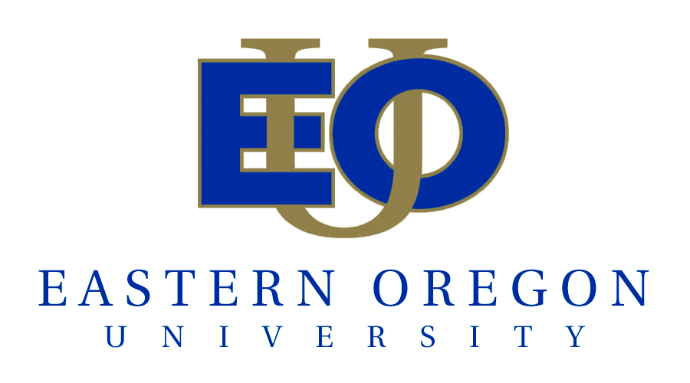

OUS CAMPUS COMPACT & OEIB ACHIEVEMENT COMPACT

Assumptions:
Each OUS institution will have a Board of Higher Education approved Campus Compact with OUS. The Board of Higher Education will recommend that these Campus Compacts be adopted by the OEIB as the Institutional Achievement Compact. The Campus Compacts/ OEIB Achievement Compacts will include all of the measures in OUS’s Achievement Compact with the OEIB as well as institution specific measures based on institutional mission, capacity, array of programs, etc.

Attainment of targets is contingent upon sufficient resources.

Eastern Oregon University Mission:
EOU guides student inquiry through integrated, high-quality liberal arts and professional programs that lead to responsible and reflective action in a diverse and interconnected world.

As an educational, cultural, and scholarly center, EOU connects the rural regions of Oregon to a wider world. Our beautiful setting and small size enhance the personal attention our students receive, while partnerships with colleges, universities, agencies, and communities add to the educational possibilities of our region and state.

EOU Institutional Core Themes & Associated Goals

Theme 1: EOU has high quality liberal arts and professional programs that prepare students for the world beyond college.
Goal 1: Foster and assess student learning
Goal 2: Ensure faculty and staff success

Theme 2: EOU is a regional University with a deep sense of commitment to students where they are.
Goal 3: Serve students where they are
Goal 4: Make excellence inclusive
Goal 5: Adopt and enhance appropriate educational technologies

Theme 3: EOU is the educational, cultural and economic engine of eastern Oregon.
Goal 6: Foster Partnerships
Goal 7: Ensure a fiscally and environmentally sustainable university environment
Goal 8: Provide programs and resources to respond to high demand regional needs

Theme 4: EOU provides personal, student-centered experience in both the curricular and co-curricular programs.
Goal 9: Ensure access and success for all students
Goal 10: Provide opportunities for students and faculty to engage with their community

Outcomes | 2010-11 | 2011-12  Target | 2012-13 Target
Completion
# of bachelor’s degrees awarded to Oregonians
# of bachelor’s degrees awarded to underrepresented minority Oregonians
# of bachelor’s degrees awarded to rural Oregonians
# of advanced degrees awarded to Oregonians
Six year graduation rate for all first-time, full-time freshmen and intra OUS transfer students
Three year graduation rate for transfer students from Blue Mountain, Treasure Valley, Mt. Hood, Chemeketa, Central Oregon, Umpqua, Columbia Gorge, and Southwestern
regardless of credits transferred
Quality
% of graduates unemployed in Oregon compared with the % of workforce unemployed in Oregon
Employer satisfaction
Alumni satisfaction
% of graduates employed or enrolled one year after graduation
# of students enrolled in partner programs²
Connections
Degrees awarded in targeted workforce areas and meet state needs
- STEM Professions
- Health Profession
- STEM Education
Research: Sponsored research expenditures
# of students who complete internships/service learning or are engaged in some form of community based learning
# of bachelor’s degrees awarded to transfer students from community colleges¹
Degrees awarded in education areas important to the institution's geographic region
(Business Administration, Education, Public Administration, Anthropology/Sociology, Environmental Studies)
Credit hours earned in distance education courses as percentage of total credit hours
% of newly admitted freshmen entering with HS dual credit and other early college credit
% of newly admitted undergraduates who are transfers from Oregon community colleges

¹ Contributions to Community College and K-12 attainment goals
² EOU partner programs: OIT/ODS—Dental Hygiene; OHSU—Nursing; OSU—Agriculture programs.

