Report Scheduling
When we add a schedule to a report, we’re actually modifying the report itself. We cannot personally change a report that is saved under the Public Folders, because those reports are shared by all users. So, if we want to schedule a report that is under the Public Folders, we need to create a Report View (a shortcut) that we can save to My Folders as your own personal copy of the report object.

If you would like to schedule a report that you created, one that is saved under My Folders, please skip ahead to step 15 in this document.

- Login to Cognos and navigate to the Production Data Warehouse

- Click on the Academic Affairs folder

- Locate the report Enrollment by Course – Student Credit Hours

- To the right, locate the icon for Create a Report View of this report (looks like a window with a plus sign)

- Click the icon

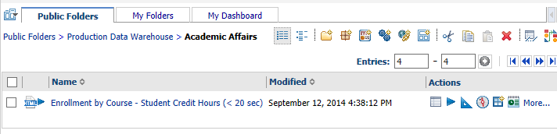

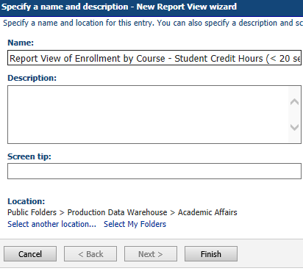
- On the New Report View wizard page, in the Location section, click Select My Folders

- Click Finish

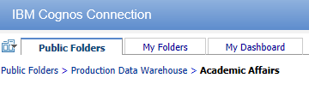

- At the top of the page, click My Folders

- Locate the item Report View Enrollment by Course – Student Credit Hours

- To the right, locate the icon for Set Properties

- Click the icon

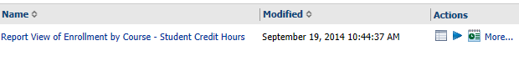

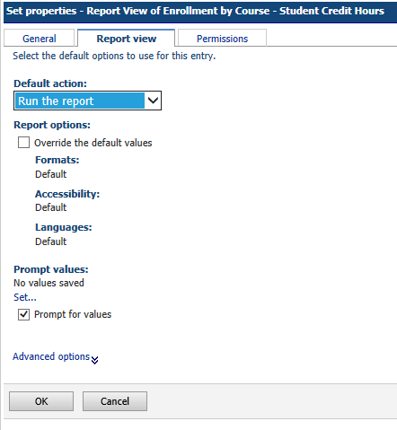

- Click on the second tab, Report view

- Change the default action to Run the report

- Click OK

- To the right of the Report View (or Report Name), locate the icon for Schedule (looks like a calendar page)

- Click on the icon

- Update the Start Time to 10 minutes from now
- Change the End Date to tomorrow’s date
- Under Options, check the box for Override the default values
- Under Formats, uncheck the box next to HTML
- Check the box next to Excel 2007
- Under Delivery, uncheck the box next to Save the report
- Check the box next to Send a link to the report by email
- Click Edit the options

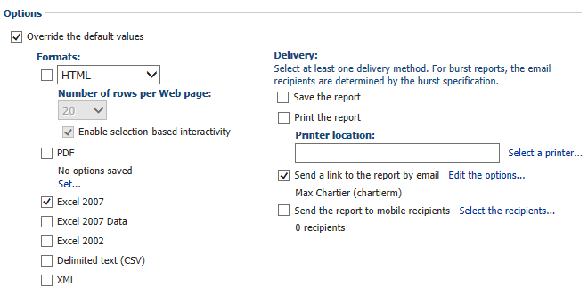

- In the email Body, type “This is a test report sent via email”

- Uncheck the box next to Include a link to the report

- Check the box next to Attach the report

- Click OK

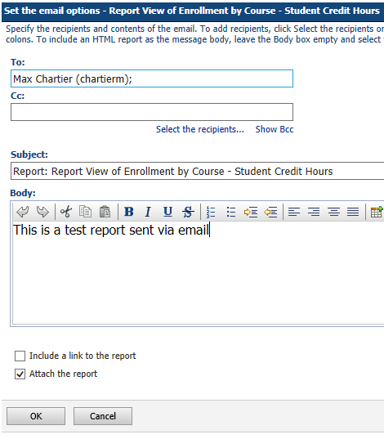

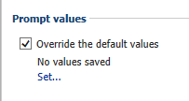
- Under Prompt values, click the checkbox next to Override the default values

- Click Set

- Use the Term dropdown to select 201401
- Use the Department dropdown to select Computer Science
- Use the Subject dropdown to select CS
- Click Finish

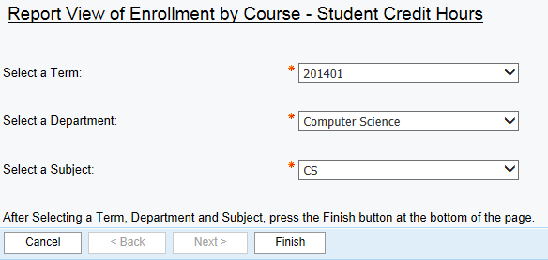

- Click OK
