Cognos Workspace Advanced
Basic Finance Report

- Login to Cognos and navigate to the Production Data Warehouse

- In the upper right-hand corner of the page, click the Launch dropdown menu

- Select Cognos Workspace Advanced

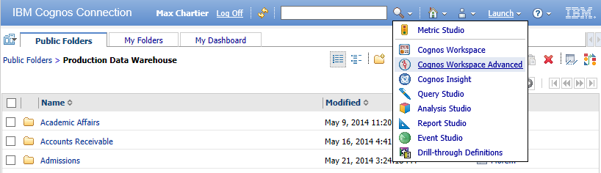

- Select Create new

- Select List

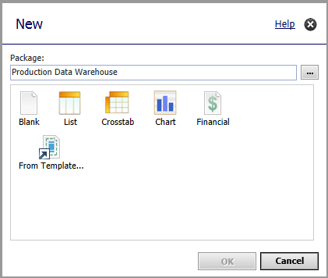
- Click OK
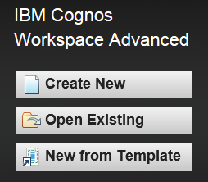

- Note the Work Area, Content pane, Menu Bar and Toolbar
Menu Bar

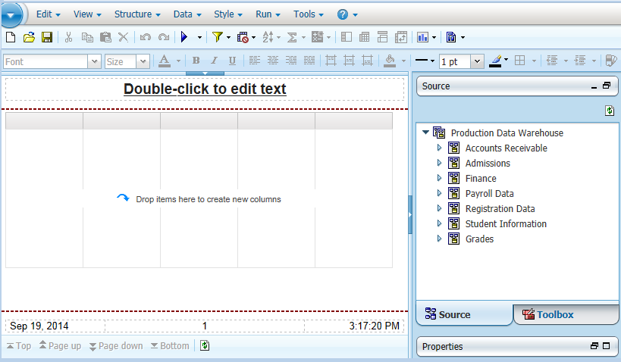
Work Area
Content
Toolbar

- By default, the report is in Page Preview mode. This means that every time you add a new field, the report will run while adding that field. To speed up report development, we can turn that off.
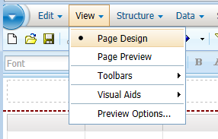
  - Click on the View dropdown menu

  - Select Page Design

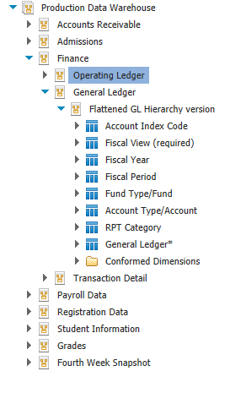
- In the Content pane, expand the folder for Finance

- Expand the folder for General Ledger

- Expand the folder for Flattened GL Hierarchy version

- Facts and Dimensions
  - Fact Table* - contains the data corresponding to a particular business process, typically numeric (Operating Ledger is an exception to this rule)

  - Dimension - contain details about each instance of an object

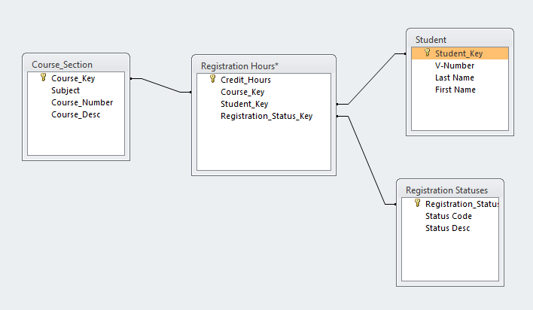

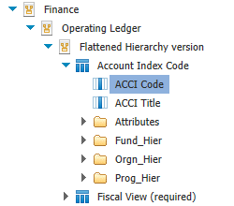
- Expand the folder for Operating Ledger

- Expand the folder for Flattened Hierarchy version

- Expand the folder for Account Index Code

- Double click ACCI Code to add it to the report

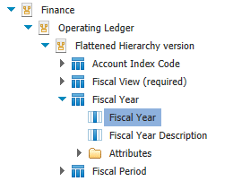

- Expand the folder for Fiscal Year

- Double click Fiscal Year to add it to the report

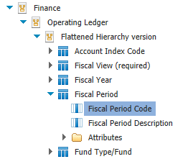

- Expand the folder for Fiscal Period

- Double click Fiscal Period Code to add it to the report

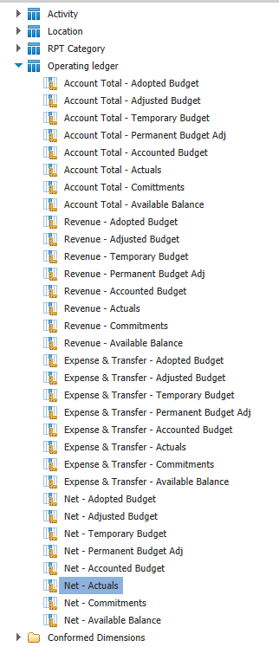

- Expand the folder for Operating Ledger
  - (this is our fact table, it contains the dollar amounts)

- Double click Net - Actuals to add it to the report

- Go back to the Account Index Code folder from earlier

- Click and drag ACCI Title to the report between ACCI Code and Fiscal Year

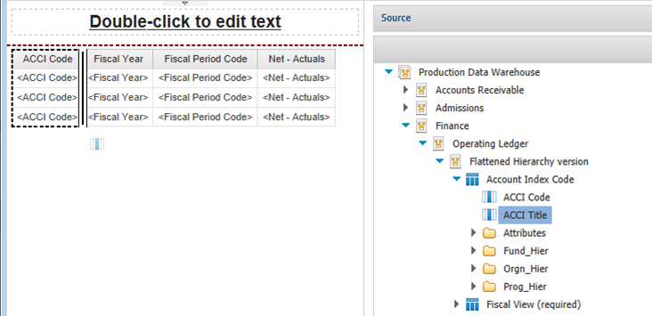

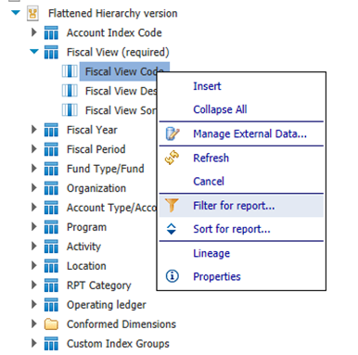
- Expand the folder for Fiscal View (required)

- Right click on Fiscal View Code

- Select Filter for report

- Single click the value Periodic then click the right arrow to add it to the Selected values pane

- Click OK

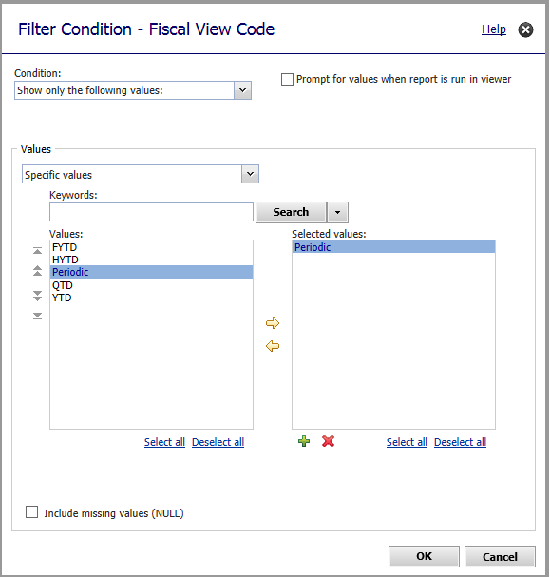

- Under Fiscal Year, right click on Fiscal Year

- Select Filter for report

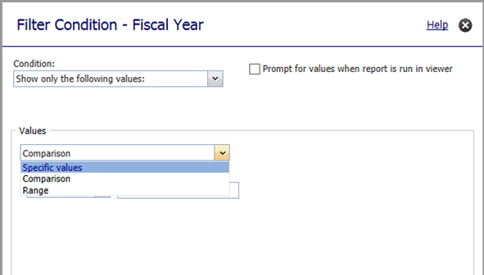
- Under Values, change the dropdown selection from Comparison to Specific Values

- In the Keywords box, type 2015 and click the Search button.

- Single click the value 2015 then click the right arrow to add it to the Selected values pane

- Click OK
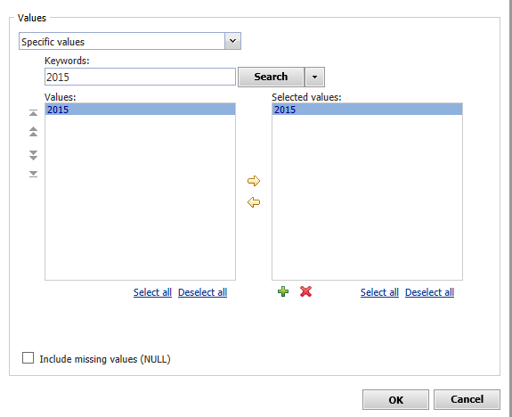

- Under Account Index Code, right click on ACCI Code

- Select Filter for report

- Type in the Keyword “GEN61” and click Search

- Double click the value “GEN611” to add it to the Selected values pane

- Double click the value “GEN614” to add it to the Selected values pane

- Click OK

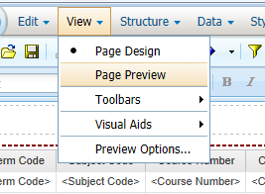
- Click on the View dropdown menu

- Select Page Preview

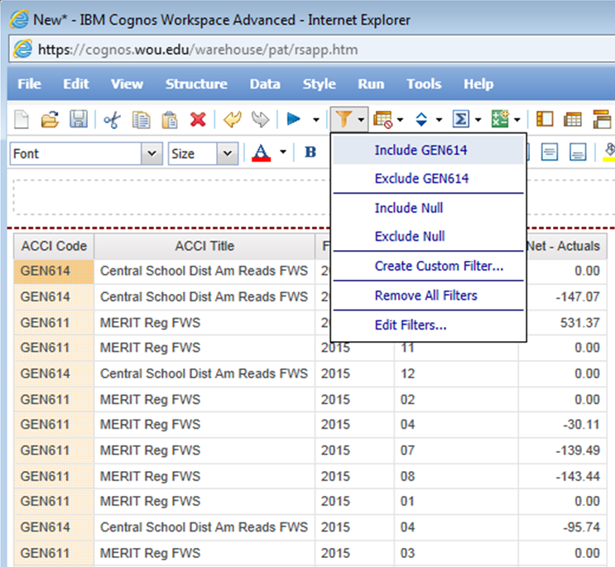

- Single click on the Index Code GEN614 to highlight it

- In the Toolbar, click the Filters button

- Click Include GEN614

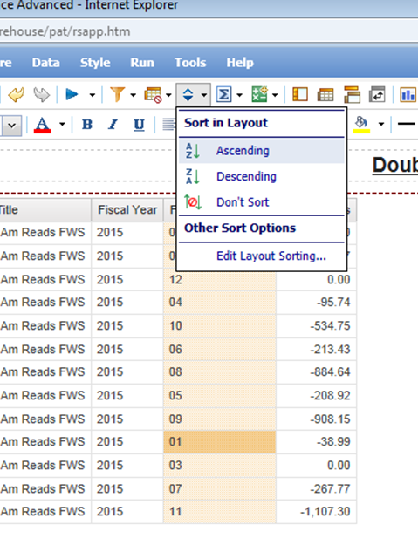

- Single click on the first Fiscal Period Code

- In the Toolbar, click the Sort button

- Click Ascending

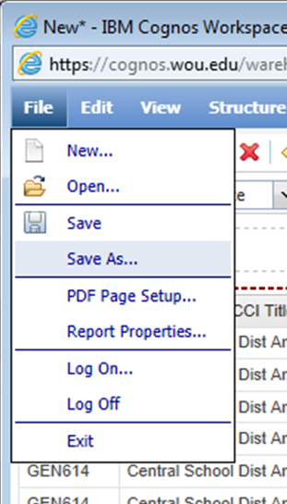

- In the Menu Bar, click File >> Save As

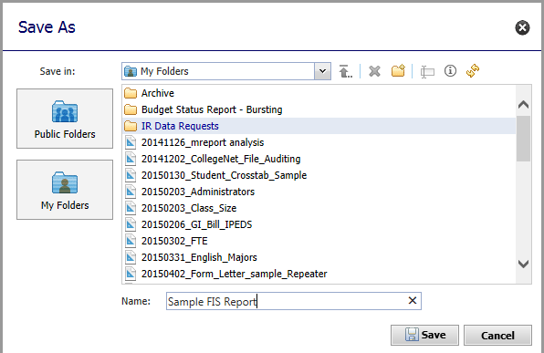

- Select My Folders

- In the Name field, type Sample FIS Report

- Click Save

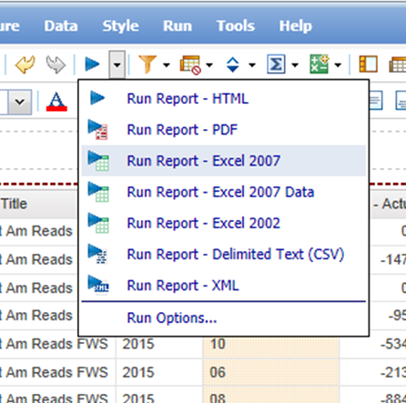

- In the Toolbar, click the dropdown next to the Play button

- Select Run Report – Excel 2007

- Click Open

