Cognos Workspace Advanced
Basic Student Report

- Login to Cognos and navigate to the Production Data Warehouse

- In the upper right-hand corner of the page, click the Launch dropdown menu

- Select Cognos Workspace Advanced

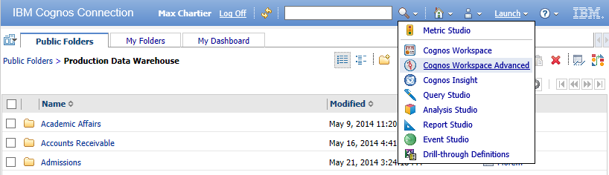

- Select Create new

- Select List

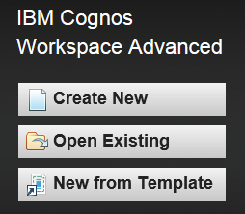
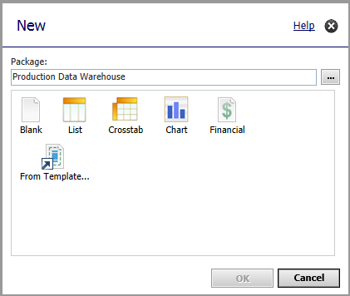
- Click OK

- Note the Work Area, Content pane, Menu Bar and Toolbar
Menu Bar

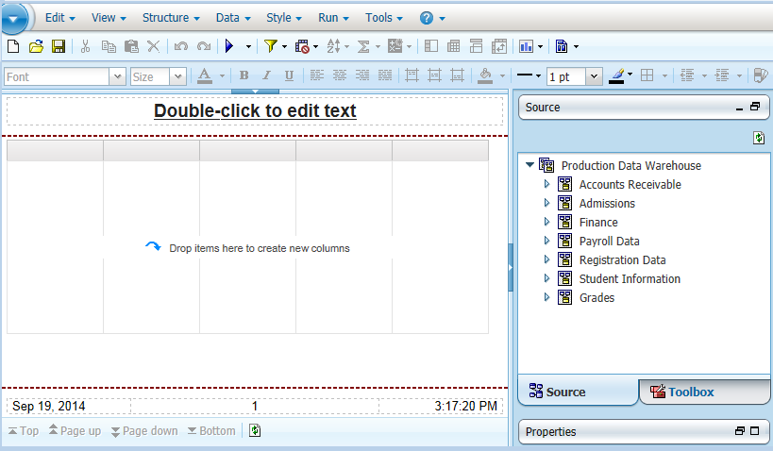
Work Area
Content
Toolbar

- By default, the report is in Page Preview mode. This means that every time you add a new field, the report will run while adding that field. To speed up report development, we can turn that off.
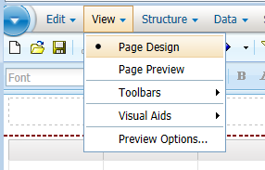
  - Click on the View dropdown menu

  - Select Page Design

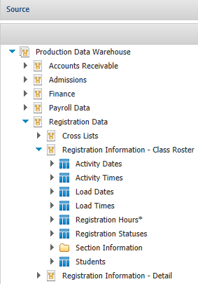
- In the Content pane, expand the folder for Registration Data

- Expand the folder for Registration Information – Class Roster

- Facts and Dimensions
  - Fact Table* - contains the data corresponding to a particular business process, typically numeric

  - Dimension - contain details about each instance of an object

Note: You must add a field from the folder with the asterisk. Also, you will get accurate data if you build your report out of one low-level yellow folder (i.e. Class Roster). Cognos doesn’t know how to connect data between folders.

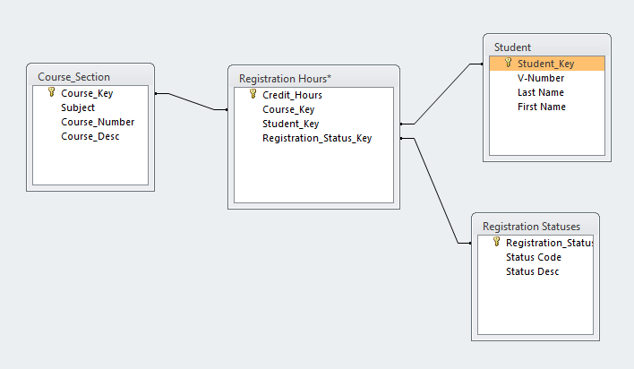

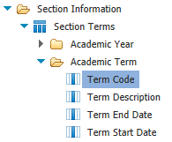
- Expand the folder for Section Information

- Expand the folder for Section Terms

- Expand the folder for Academic Term

- Double click Term Code to add it to the report

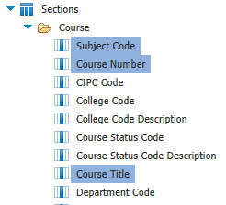
- Expand the folder for Sections

- Expand the folder for Course

- Double click Subject Code to add it to the report

- Double click Course Number to add it to the report

- Double click Course Title to add it to the report

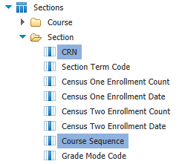

- Expand the folder for Section

- Double click CRN to add it to the report

- Double click Course Sequence to add it to the report

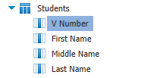

- Expand the folder for Students

- Double click V Number to add it to the report
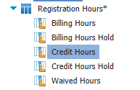
- Expand the folder for Registration Hours

- Double click Credit Hours to add it to the report

- Go back to the Students folder from earlier

- Click and drag Full Name to the report between V Number and Credit Hours
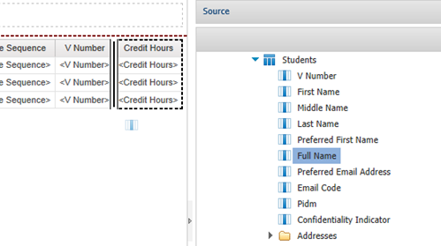
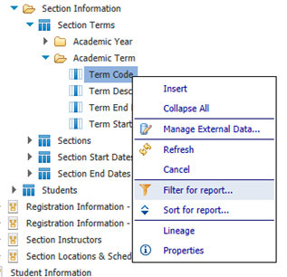

- Under Section Terms >> Academic Term right click on Term Code

- Select Filter for report

- Under Values, in the dropdown, select Specific values

- Type in the Keyword 201401 and click Search

- Single click the value 201401 then click the right arrow to add it to the Selected values pane

- Click OK

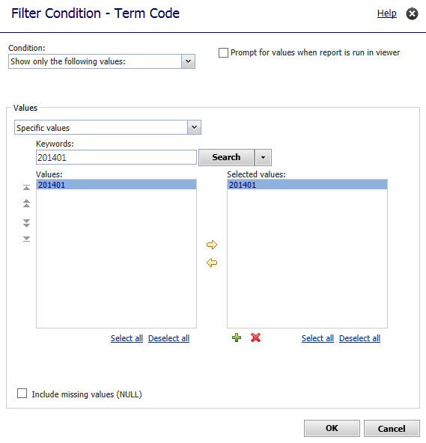

- Under Sections >> Course, right click on Subject Code

- Select Filter for report

- Type in the Keyword CS and click Search

- Single click the value CS then click the right arrow to add it to the Selected values pane

- Click OK

- Under Sections >> Course, right click on Course Number

- Select Filter for report

- Type in the Keyword 123 and click Search

- Double click the value 123 to add it to the Selected values pane

- Click OK

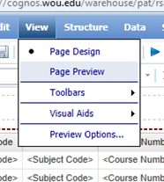
- Click on the View dropdown menu

- Select Page Preview

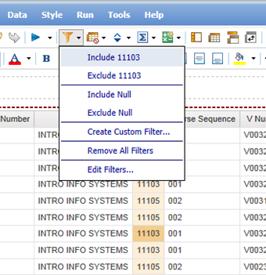

- Single click on the CRN 11103 to highlight it

- In the Toolbar, click the Filters button

- Click Include 11103

- Single click on the first Full Name in the list of names

- In the Toolbar, click the Sort button

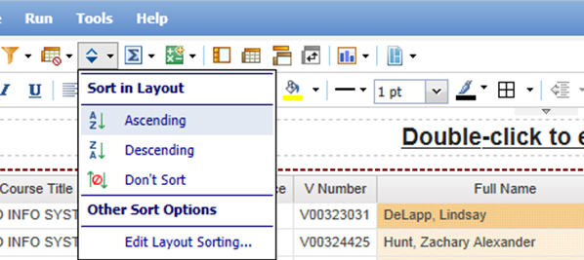
- Click Ascending

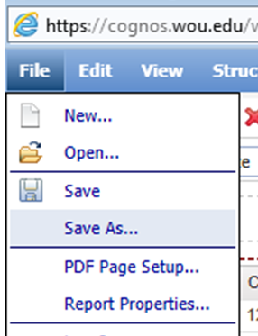
- In the Menu Bar, click File >> Save As

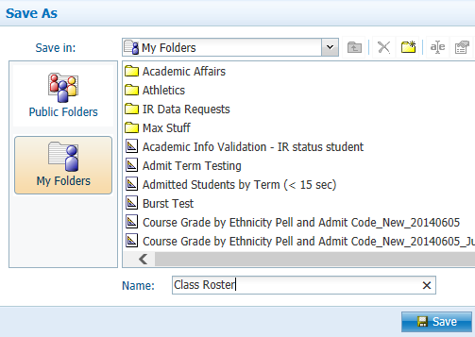
- Select My Folders

- In the Name field, type Class Roster

- Click Save

- In the Toolbar, click the dropdown next to the Play button

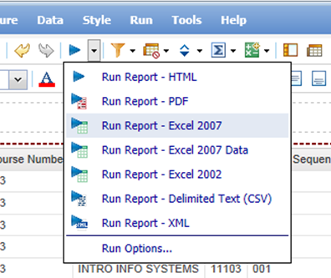
- Select Run Report – Excel 2007

- Click Open

