Cognos Basics

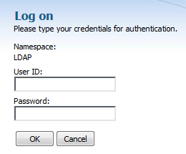
- Login to Cognos
  - Use the Cognos button on your Portal homepage

  - Open a web browser and navigate to https://cognos.wou.edu/warehouse

    - Enter your User ID

    - Enter your Password

    - Click the OK button

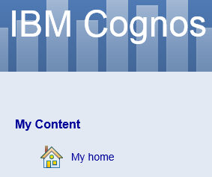
- Navigate within Cognos
  - The default landing page is the Welcome Page

  - Click on My home

*Tip: You can bypass the Welcome Page in the future by unchecking the checkbox next to “Show this page in the future”

  - Click on Production Data Warehouse

  - You should now see the folder structure that separates reports into functional areas

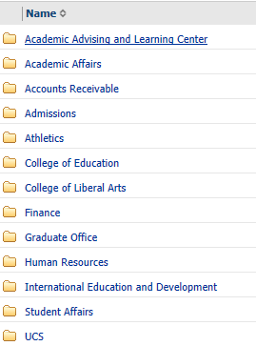
*Tip: You can display gridlines in between rows of folders and reports by going to My Preferences

  - Note the different icons for folders, packages and reports

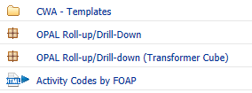

  - Breadcrumbs at the top of the page will lead you back to the top level

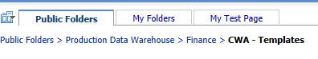

- Run a report
  - In the Production Data Warehouse, click the Academic Affairs folder

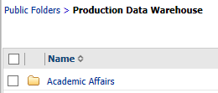

  - Click Class Roster by CRN

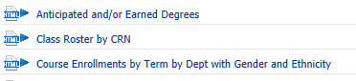

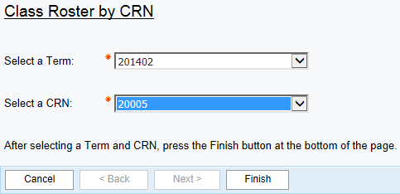
  - Click the Section Term dropdown
  - Select 201402
  - Click the CRN dropdown
  - Select 20005
  - Click the Finish button at the bottom of the page

  - A report has multiple pages if the Page down and Bottom links are active at the bottom of the report

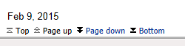

  - Click the dropdown menu in the upper right-hand corner of the page indicated by an HTML label

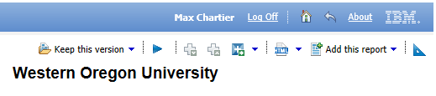

  - Click View in PDF Format

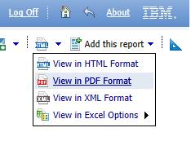
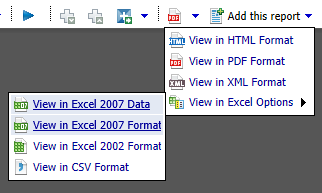
  - Click the dropdown menu in the upper right-hand corner of the page now indicated by a PDF label

  - Click View in Excel Options

  - Click View in Excel 2007 Format

  - Click Open

