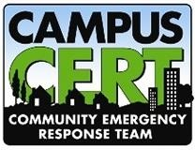
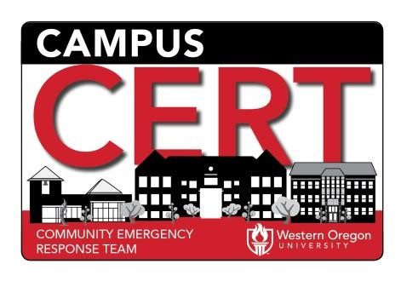
WOU CERT (Community Emergency Response Team)
WOU Campus Public Safety Department
3445 N. Monmouth Ave, Monmouth, OR 97361
(503) 838-8481 Rechc@mail.wou.edu

CERT Member Application 2023

PERSONAL INFORMATION
__________________________________________________________________________________________________
Last Name First Name (Full) Nickname Middle Initial
__________________________________________________________________________________________________
Residential Address City County Zip
__________________________________________________________________________________________________
Home Phone Work Phone Cell Phone Email Address
__________________________________________________________________________________________________

Employer Name Address Work Email

Membership Requirements:
- Adult Team members must be a minimum of 18 years of age. Ask your Coordinator for further information. • Members are required to hold and maintain a valid Driver’s License, (as is age appropriate).
- Licensed Members who use their own vehicles in the performance of their duties for WOU CERT may be asked at any time to provide proof of a current vehicle insurance policy.
- Your Occupation: _____________________________________________________
- Hobbies, Skills, Interests: _____________________________________________________
_____________________________________________________
- Previous Volunteer Experience (if any): __________________________________________
- How did you find out about the CERT basic training? _______________________________
- Resources: Can you run heavy equipment or do you have access to equipment that could be used during a disaster? (Tractors, chain saws, backhoes, et cet.):
______________________________________________________________________________
______________________________________________________________________________

Disclaimer of Liability
As a volunteer participant of the Community Emergency Response Team Training through WOU CERT, an organization collaborating with first-responding agencies in the Polk County area, I understand and agree to the following:
    - I am a volunteer. I agree to abide by the policies and procedures of the CERT program to ensure the safety of myself and all others.
    - My participation may at times involve some physical activity. If I have any physical limitations, I will make my trainers and team leads aware of those limitations and am aware that no requirements will be placed upon me by the CERT organization or its trainers that would cause injury to my person, or cause me to overextend myself beyond my limitations.
    - WOU CERT makes every effort to ensure the safety of its members. I am participating in these activities and
meetings at my own risk. I will make no claim for damage against WOU CERT it its sponsoring agencies or trainers should I become injured during a drill, activity or deployment. I will ensure that I have insurance coverage or am able to pay any medical expenses incurred as a result of an injury during my involvement with WOU CERT.

__________________________________ | _______________________
Signature of Participant | Date
__________________________________ | _______________________
Signature of parent (if participant is under 18) | Date

Consent to Criminal History & Background Check.

  - In order to maintain the safety of our members and the community we serve, WOU CERT requires that every member be cleared of any criminal history that is deemed inappropriate to the performance of our duties. This will include a full background check and a search of local police databases for number/type of contacts.
  - Your criminal history may be re-checked on an annual basis.
  - CERT members are required to report any ODL suspensions, loss of drivers license or any criminal arrests to the CERT coordinator within 1 week of the incident.
  - The results of your criminal history/ background check may be made available to multiple First Responder Agencies in Polk County including Law Enforcement, Fire and EMS Services.

“By my signature below I acknowledge my understanding of and agreement to the items bulleted above, and hereby consent to allow WOU CERT, through the Campus Public Safety office, to perform a complete background check of my criminal history. I am aware that the results can and will be used as part of the decision process regarding my acceptance into the WOU CERT Organization. I understand that the results of the criminal history/background check will not be made available to me upon my request.”

___________________________________________________________________________________________________________
Signed Name Printed Name Date Signed

___________________________________________________________________________________________________________
Signature of Parent (if participant is under 18) Printed Name Date Signed

___________________________________________________________________________________________________________
Current / Valid Driver’s License # State Issued Expiration Date

Criminal History Results

___________________________
Date Criminal History Performed

___________________________________________________________________________________________
Performed By Agency Position

Results were viewed by:

Rebecca Chiles, VP, Campus Public Safety & Facilities Director on (Date) _________________________

Chris Rech, WOU CERT Program Manager on (Date) _________________________

Other ____________________________________ on (Date) __________________________

Based on the results this application for membership into WOU CERT has been:

Approved

Denied for the following reasons: ____________________________________________________

