FAICARD – FAST FIS

Purpose & Use: To verify distributions have been completed and view the history of all purchases made on a specific P-card.

Type FAICARD in the Search box, press [Enter].

The Purchase Card

The Purchase Card Query screen will appear, enter a % and the last four digits of your Pcard in the Card Account Number box:
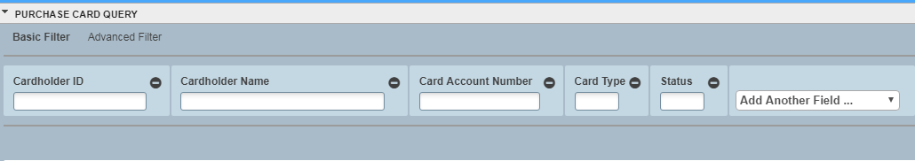
Enter % and last 4 digits of Pcard number here.

Click [Go] or press [Enter].
The card information will appear with card details. Click the down arrow.

Transaction Details:

All transaction purchase history of the card will appear.
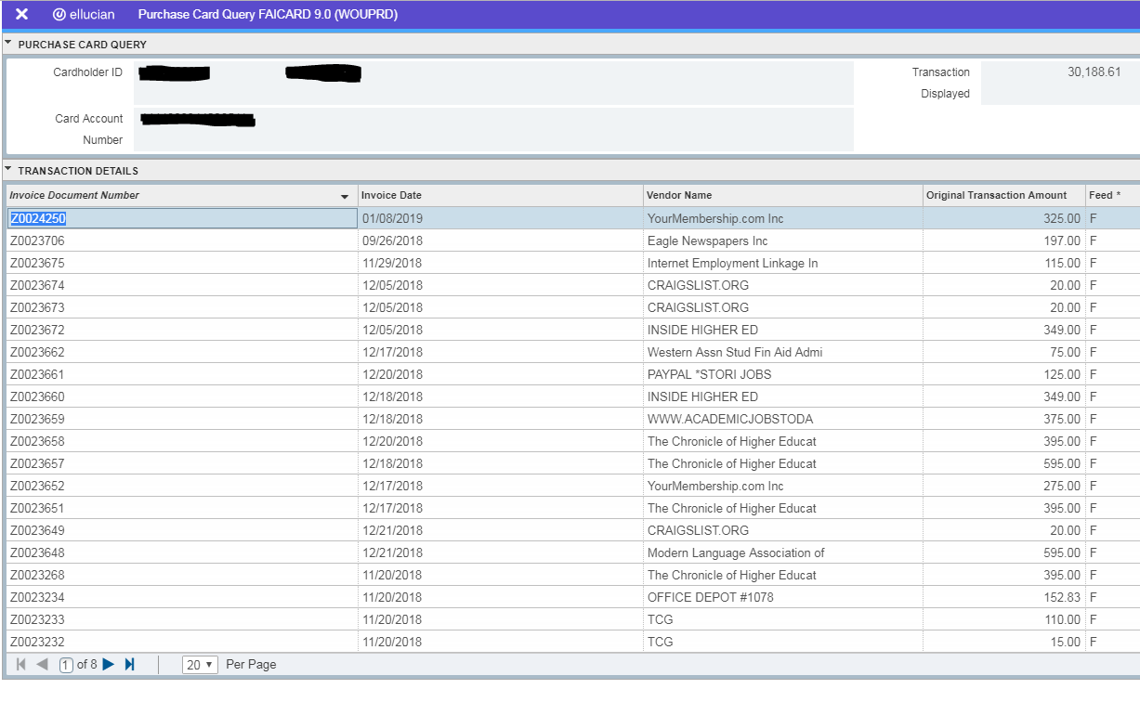

Invoice Document Number: If a Z number appears, the transaction for the line has been distributed and reflects in your budget. If a Z number is absent, the transaction has not been distributed or pending distribution (distributions made during the day will feed into banner at 4:30 P.M.).
Invoice Date: is the purchase date.
Feed: The F denotes fed and N unfed transactions in the Feed Column.

