FAST FIS

How to distribute a Purchase Card (P-Card) Transaction- FAAINVT

Objective: To apply expense/purchase to the appropriate department index.

Type FAAINVT in Search box, press [Enter].

Purchase Card Transaction Maintenance

To access your P-card info please enter your Budget authorities V number and your username or quickly access your information with your username.

Cardholder ID: Budget authority V-Number
Account Manager ID: Custodian username
Type: Not Fed Transaction (default) Note: if you enter your username and an error message appears you may have no transactions to distribute.
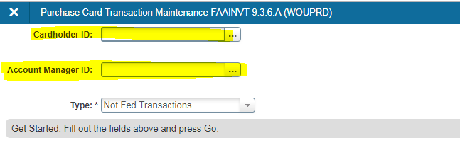
Click on the Go icon.

Cardholder Information Block

P-Cards with “Not Fed Transactions” will be listed for the Account Manager or Business Manager entered in the Key Block. For Custodians with multiple P-cards assigned, use the arrow keys to scroll though the P-cards, stop on the P-card you wish to distribute.

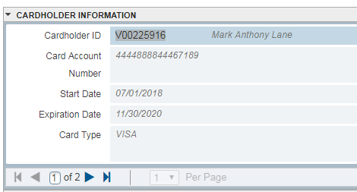
Blocks
To get to one block to another click on the icon or click on Alt+PageDown or Alt+PageUp.
Vendor Information Block

This block is informational only and displays vendor details in relation to the transaction you made. Do not make any changes in this block.

To view each transaction please use the arrow keys to scroll through.

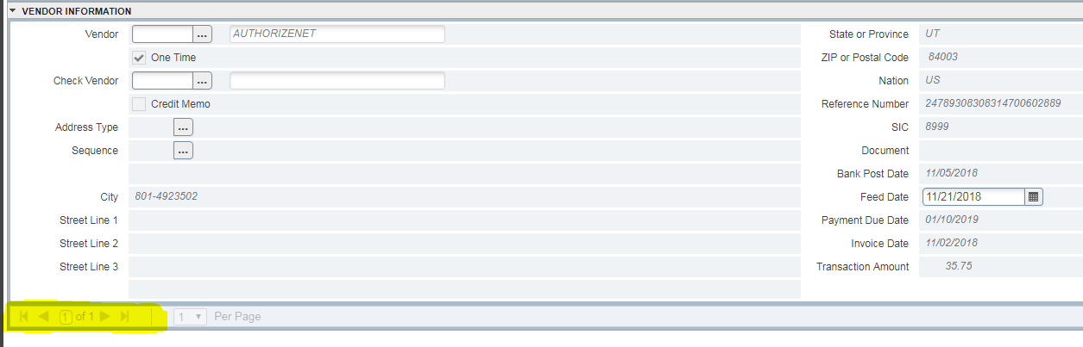
Once you scroll thought the transactions, stay on the transaction you would like to distribute. Click on the arrow down button to go to the next block.

Default Accounting Distribution

Commodity: Leave the first section black, it should always be left blank. In the second field, type a detailed description of the purchase (maximum 50 characters). There is only one commodity line for each transaction.

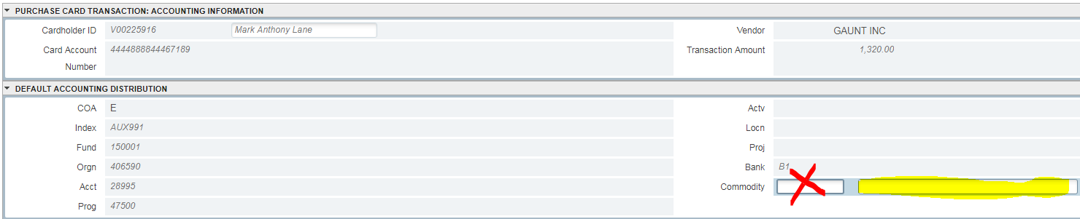
Click down to the next block.

Details

The default accounting for this card will display. Make any needed changes to the accounting elements or distribution amounts here. At a minimum, you are required to update the account code to accurately reflect the commodity/service purchased. Transactions with account code 28995 will not post to Banner. You can add as many accounting lines as needed to distribute the transaction. You can also list out amounts or percentages.

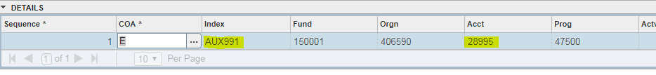
COA: Defaults to E. Leave as is
Index: Replace the default index if necessary.
Fund: Defaults from Index Normally leave as is.
Orgn: Defaults from Index. Normally leave as is.
Acct: Defaults to 28995 and must be replaced with an appropriate account code.
Prog: Defaults from Index. Normally leave as is.
Actv: Enter the correct code if one is needed (optional field)
Bank: ‘B1” is always used for these invoices. Be sure to add it to additional accounting lines created.

Once you have made all your changes click the save button.
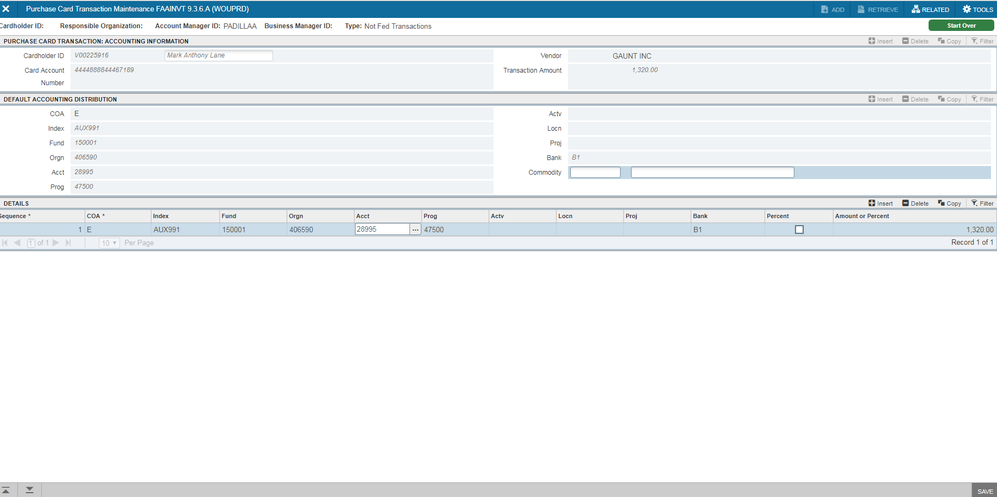

To continue distribution transaction for the same card:

Click the up arrow box until you are returned to the Transaction Information Block. Use the up/down arrows to select the next transaction to distribute. Repeat the above steps until all transactions have been distributed.

Note: transactions will still appear in banner until the changes are fed into banner, transactions are fed into banner at 4:00pm on a daily basis. To verify your transactions have successfully been fed into banner, log back in into FAAINVT at 4:30pm the same day. If they were successfully fed, you will receive and error message indicating you have unfed transactions or use FAICARD (see FAICARD FAST FIS) to view that each transaction has an assigned “Z” number.

