VENDOR SEARCHES
Vendors include external entities, contractors, employees and students. To find if a vendor exists in Banner go to FTIIDEN (Entities/Vendor Search form). Below is the instructions for a vendor query. This information is also available in the FAAINVE Banner Invoice instructions.

Go to the Entity Name/ID Search form (FTIIDEN). Uncheck the Vendors box and check the All
box. Click in the Last Name field and enter name of the vendor. (It is case sensitive so you
may want to use the “%” wildcard. Ex. Boise%.) To execute this query, press F7, or click
Query>Execute in the Toolbar. If the vendor exists in Banner you will see the V0xxxxxx number
(vendor number) and vendor name. If the vendor is not found after a thorough search, you
should have the vendor complete the WOU Substitute W-9 form (US entities) or W-8 form
(foreign entities).

VENDOR SET UP
WOU Substitute W-9 form
The Business Services Accounts Payable Accountant is responsible for vendor set up and maintenance. To set up a new vendor in Banner, submit a current WOU Substitute W-9 form (US entities) or W-8BEN form (foreign entities) and a document with your name, department, and phone number to Lucinda Milligan, Business Services.
The WOU Substitute W-9 form is available at:
https://www.wou.edu/business/services/forms

W-8BEN form – Please contact Susanne Hart, Business Services, at harts@wou.edu regarding information for setting up foreign vendors.

ADDRESS CHANGES
If the vendor has a new address, email Lucinda Milliagan (milliganl@wou.edu) a copy of the invoice along with a request to set up a new address.

TAX ID CHANGE
If the vendor has a new tax ID, they will need to complete a WOU Substitute W-9 form. Submit the form and a document with your name, department, and phone number to Lucinda Milligan, Business Services.

TERMINATED VENDORS
A vendor is terminated in Banner when they fail to provide a valid social security number or tax ID or they are no longer in business. A terminated vendor may be re-activated if their new social security number or tax ID can be verified in the Social Security Administration or IRS database. A terminated vendor is identified with a T in the V column (vendor) in the Vendor Search form FTIIDEN (pictured below).

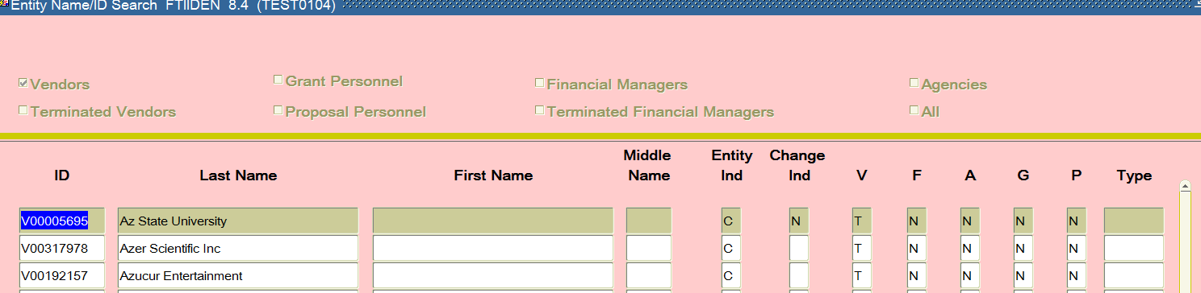
This is a terminated vendor

