What is Educational Psychology?
Educational Psychology is a branch of psychology that investigates the social, emotional and cognitive processes involved in learning. Educational Psychologists apply their findings to improve the learning process. Some specialize in the development of a specific group of people such as children, adolescents or adults, while others focus on specific challenges such as attention deficit hyperactivity disorder (ADHD) or dyslexia (APA, 2016)

Educational Psychology Minor Mission
Provide students with an interdisciplinary foundation of knowledge and skills drawn from the fields of psychology and education. Students will develop critical thinking skills and apply research to improve learning, behavior, and mental health.

Educational Psychology Minor
Learning Outcomes

1. Use critical thinking in analyzing theory, research, and practice related to educational
psychology.

2. Demonstrate understanding of complex cognitive, physiological, social, and motivational influences on learning, behavior, and mental health.

3. Explain current approaches to assessing outcomes across diverse environments and
populations.

Education Psychology Minor: Coursework
The educational psychology minor should be planned with an advisor and consists of 28-29 credit hours, of which at least 15 hours must be upper division. All students complete a required core, and then choose from elective options. Electives must include at least 6 hours of ED or SPED courses.

Core (13 or 14 credits)
PSY 201  or  PSY 218 | General Psychology  or  Psy Foundation of Ed | 4 cr.  or  3 cr.
PSY 360  or  PSY 390 | Cognitive Psychology  or  Theories of Learning | 4
ED 200  or  ED 220  or  SPED200 | Foundations of Ed  or  Intro to Early Child Ed  or  Careers in Human Services | 3
ED 481 D | Intro to ESOL & Bilingual ED | 3

Electives: (15 – 16) Must include at least 6 hours of ED or SPED coursework
ED 230  or  ED 240 | Children’s Literature in Diverse Classrooms  or  Young Adult Literature in Diverse Classrooms | 3
ED 231  or  ED 233  or  ED 242 | Typical & Atypical Dev,  or  Applied Adol Learning & Dev  or  Applied Child Learning & Dev | 3
ED 322 | Early Childhood Motor Development and Movement Education | 3
ED 232 | Health and Safety Practices in the Early Childhood Environment | 3
ED 324 | Creative Arts in Early Childhood Settings | 3
ED 345 | Designing Early Childhood Environments | 3
ED 348 | Developmentally Appropriate Practices: EC Play, Development & Literacy | 3
ED 259  or  ED 250  or  SPED 418 | Special Education,  or  Inclusive Practices in Early Childhood Settings,  or  Survey of Special Ed | 3
ED 380 | Infant and Toddler Development | 3
ED 484 | First and Second Language Acquisition & Educational Linguistics | 3
SPED 447 | Partnerships in Special Ed | 3
PSY 301W | Intro to Research Methods | 4
PSY 311 | Developmental Psychology | 4
PSY 349 | Intro to Behavior Modification | 4
PSY 410  or  PSY 411 | Mentoring I  Or  Mentoring II | 4
PSY 438 | Theories of Personality | 4
PSY 449 | Psychology of Creativity | 4
PSY 458 | Language Development | 4
PSY 463 | Childhood Psychopathology | 4
PSY 465 | Motivation | 4
PSY 480 | Infancy and Childhood | 4
PSY 482 | Adolescence | 4

Educational Psychology Advisors
Contact the Behavioral Sciences Division Office
503-838-8344 or kunzel@wou.edu

Employment Opportunities

According to the Occupational Outlook Handbook (2016) employment opportunities for individuals with knowledge and skills in Educational Psychology can include
- Educational Specialist
- Educational/Vocational Counselor
- Educational Software Consulting
- Teaching
- Special Education
- Instructional Specialist
- Early Intervention Specialist
- Academic Advisor
- Career Center Director
- Research assistants
- Social service case workers
- Treatment providers

Individuals with a minor in Educational Psychology could go on to pursue graduate training in the following areas (APA, 2016)
- Clinical or counseling psychology
- Social work or therapy
- Educational Psychology
- Instructional Psychology
- School Psychology
- School Counseling
- Speech and Language Therapist

References
American Psychological Association (APA) (2016). Understanding educational psychology. Retrieved from http://www.apa.org/action/science/teaching-learning/

Occupational Outlook Handbook (2016) Bureau of Labor Statistics. U. S. Department of Labor, Occupational Outlook Handbook, 2016-17 Edition, Psychologists, http://www.bls.gov/ooh/life-physical-and-social-science/psychologists.htm
Frequently Asked Questions
- How would a minor in Educational Psychology help me?

The Educational Psychology minor provide students the ability to develop skills that are in demand across a range of settings working with diverse learners (Occupational Outlook Handbook, 2016). A list of employment opportunities related to Educational Psychology appears to the left.

- My major is psychology. Can I minor in educational psychology?

Yes, any major can be combined with a minor in the educational psychology program. However, if a class is used for the minor (e.g., PSY 201) it can’t also be used for the major. In other words, students cannot “double-dip” or use the same course for your major and minor. Course substitutions are required for such classes. See your advisor for more information.

- Do any of these classes have prerequisites?

Yes, a few courses do have prerequisites. There are prerequisites for all of the psychology courses which can be satisfied by (1) taking PSY 201 and PSY 202, one of which can count for the “additional social science course” needed for Liberal Arts Core Curriculum (LACC). Some Psy classes also require other prerequisites. See your advisor for more information Some ED and SPED courses have pre-requisites. Check the catalog to determine if a course has pre-requisites.

- Is a practicum or internship required for this minor?

No, a practicum is not required but it is encouraged as a great way to get real-world job experience and make connections in the field. See your advisor for more information.

Educational
Psychology
Minor

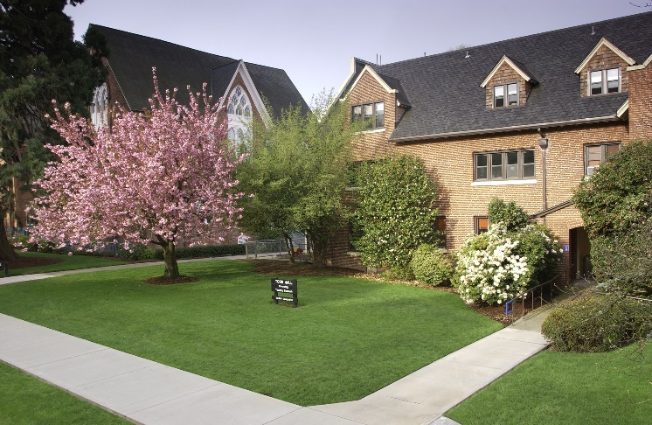
Todd Hall

www.wou.edu/behavioralsciences

2018-2019

